81/81A Service
Sample fare prices
The 81/81A service is the only direct service that links Dedham, Langham and the surrounding villages with Colchester Town Centre during the day Monday-Saturday (excluding bank holidays). This service operates approximately every 2 hours from 0728-1931 Monday-Friday from Dedham and 0728-1813 on Saturdays, and 0930-1740 from Colchester, Monday-Saturday offering great value for money.
This service is operated by Panther Travel on behalf of Essex County Council and they set the fares. All passengers 16 years and over will need to pay the adult fare. If you travel before 9 am Monday to Friday, you will also need to pay the peak fare.

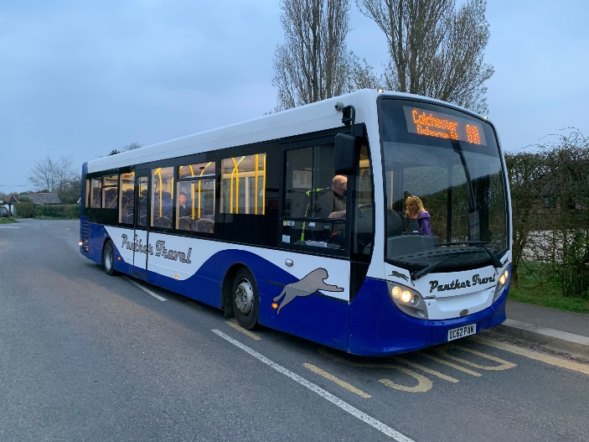
Sample fares
Adult Pk Return £5.60
Dedham or Langham to Child Pk Return £2.80
Colchester N/W/Schools Adult off Pk Return £4.60
Child off Pk Return £2.30

Adult Pk Return £4.20
Langham to Child Pk Return £2.10
Colchester Town Centre Adult off Pk Return £3.50
Child off Pk Return £1.80

Essex County Council Concession passes are valid on our service after 9am Monday-Friday and all day Saturdays.

We also offer termly and yearly passes for students in full time education under the age of 18. These passes are valid Monday-Friday school days only and are available in advance from our office.

 | Autumn | Spring | Summer | Yearly
Dedham or Langham - Col Town Centre or N/W/Schools | £156.11 | £118.85 | £143.69 | £363.80
Langham to Col Town Centre | £123.26 | £94.10 | £113.54 | £285.80
Cuckoo Point to Col N/W/Schools | £129.83 | £99.05 | £119.57 | £301.40
Cuckoo Point to Col Town Centre | £123.26 | £94.10 | £113.54 | £285.80

Alternatively you can purchase an Essex Saver Ticket for £10.00 from the driver and this is valid for the whole day on most bus services across Essex. Please go to this link for more details
http://www.essexhighways.org/Getting-Around/bus/Fares-and-bus-passes/ecc-tickets.aspx#1
The bus will stop at all registered bus stops along the route if a passenger signals for the bus to stop.
If you require further information please do not hesitate to call us on 01255 554974 or visit
www.panther-travel.co.uk
These fares are correct at time of printing, but prices can be withdrawn or adjusted at any time. Revised August 2020

